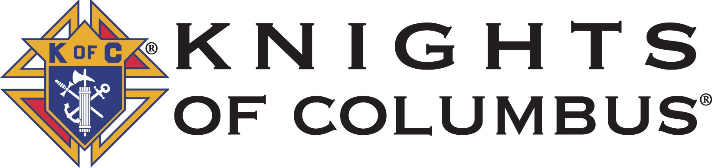
Council 763 Everett, WA

Thank you for your interest in our scholarship program. This year we are awarding a $2500.00 scholarship to the son or daughter of one of our members. It is a privilege for us to be a part of your continuing education process. The deadline for submitting all the required documents is May 1.
Along with your completed scholarship application also send two essays. The first should give a summary of your past parish activities, note your Confirmation date if you have been Confirmed, and explain how you are continuing your religious education and in what ways are you applying these lessons to your daily life. The second should discuss your academic aspirations, a summary of your school and extracurricular activities, and community volunteering experiences, especially those you have done with the Knights of Columbus, and a statement of your life goals.
Please also submit your two letters of recommendation, have your school send a transcript directly to the scholarship chairman, and have the bottom section of the high school information sheet verified by a faculty member. We have left an area for them to write their comments, and encourage them to do so.
Due to lasting impacts from the COVID 19 pandemic, the scholarship committee acknowledges that there may be difficulties obtaining some of the required information. If you have any questions about the application please contact the scholarship chairman

Send all materials to:

Scholarship Chairman
kofc763@kofc763.org
2913 W. Marine View Drive
Everett, WA 98201

Knights of Columbus Council 763 Scholarship Rules of Eligibility and Information

- Eligible Candidates must be a son or daughter of a council 763 member in good standing.

- All applicants must be an active, practicing Catholic.

- All applicants for this scholarship will be high school graduates or be graduating this school year and have been accepted by a college or university as a regular full time matriculated student with the intention of a Bachelor Degree.

- An official high school transcript will be sent directly from a school official to the scholarship chairman.

- Please provide two letters of recommendation from a religious, academic, or a civic source.

- The committee will make a selection from amongst the qualified applicants and deliver notification to the Grand Knight and the council. Their decision is final.

- The applications will be scored on a point system that includes religious, academic, and civic excellence with a consideration for a financial hardship. The names of all applicants will remain anonymous throughout the selection process.

- The Scholarship Chairman must receive a copy of a letter of acceptance from the college or university indicated in the application before the actual award is made.

- All forms and documentation must be postmarked by May 1 and addressed to:

Scholarship Chairman
kofc763@kofc763.org
2913 W. Marine View Drive
Everett, WA 98201

- Electronic submittals of required forms and documentation must be sent to kofc763@kofc763.org by May 1. Letters of recommendation must be received from the recommender, transcripts must be received directly from school officials and test scores must be received from the testing agency.

Scholarship Application

Name of Applicant

Address
Street city Zip

E-­‐‑mail Phone
Home cell

Parish

I am applying for the Knights of Columbus Scholarship for

Name of college or university

Address
Street City State Zip

I affirm that I have read the Rules of Eligibility and that the information provided in this application process is true and complete.

Signature of applicant Date

Parent or Guardian
Name

If your family is experiencing a financial hardship that is jeopardizing your student’s ability to obtain a college education please write a summery of this hardship below or on a separate sheet of paper and send it to the scholarship chairman. It will be kept strictly confidential.

I hereby consent to the application process and the rules of eligibility set forth in this process.

Signature of Parent or Guardian Date

Applicants name

High School Information

Name of High School Phone Number

-­‐‑
Principal Counselor

My GPA is on a point scale.

My class rank is out of______.

SAT scores: Critical Reading, Math, and Writing

ACT Score

How many credits does your high school require for graduation?

How many credits have you earned by January 1, of your senior year? ______________

Do you have any college credits?

Name any awards you have received in high school:

Do you have a recommendation or any further information that should be considered in this process?

